Attachment No 2
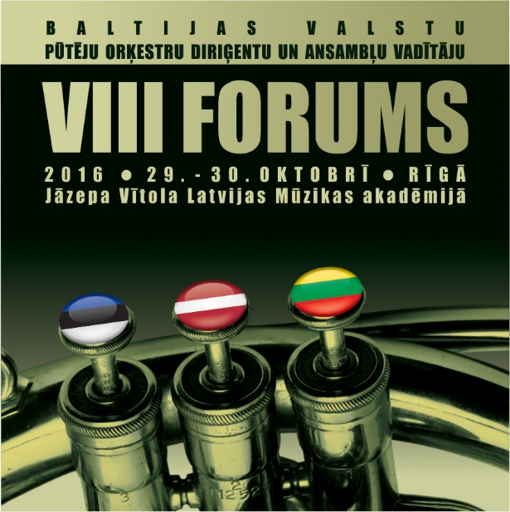
VIII Forum of the Baltic States
Wind Orchestra Conductors and Ensemble Leaders
Application Form

October 29 and 30, 2016
Jāzeps Vītols Latvian Academy of Music
Riga, Kr. Barona Street 1

First Name, Last Name: ……………………………………..

Date of birth (day/month/year)................................................

Home Address:........................................................................

Phone:…………………………..e-mail ……………………

Company, current position: …………………………….…..

Specialty: .....................................
Are you currently holding a position as an orchestra conductor or ensemble leader?

Yes (Tik): ..................................

Do you need accommodation? – No, Yes ( dormitories, hotel) *

Please send the application form by October 15 to astrida.kenina@lnkc.gov.lv
Participation fee 30, - EUR , students 20.,-EUR
Payment has to be made by October 23

Latvijas Nacionālais kultūras centrs
Reg.no.LV90000040726
Address: Pils laukumā 4, Rīgā, Latvijā, LV-1365
Valsts kase
Account number. LV87TREL2220553004000
Code: TRELV22
Please provide your payment (account) information for the invoice purposes ..............................................................
,,,,,,,,,,,,,,,,,,,,,,,,,,,,,,,,,,,,,,,,,,,,,,,,,,,,,,,,,,,,,,,,,,,,,,,,,,,,,,,,,,,,,,,,,,,,,,,,,,,,,,,,,,,,,,,,,,,,,,,,,,,,,,,,,,,,,,,,,

* Accommodation expenses are not covered by the participation fee.

