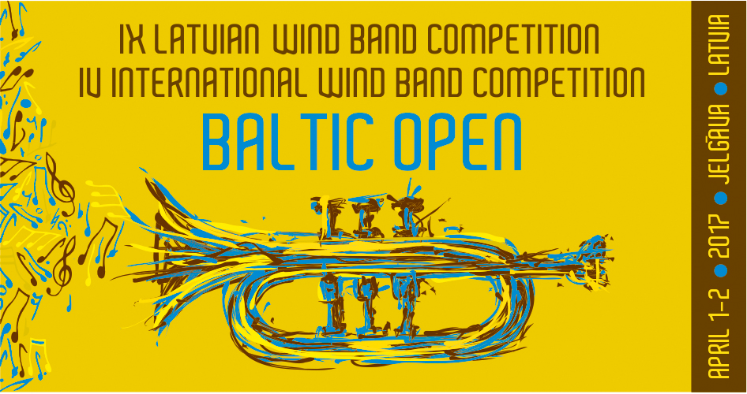

IX Latvian Wind Band Competition and
IV International Wind Band Competition BALTIC OPEN
Regulations

General Regulations

- These regulations determine the order in which IX Latvian Wind Band Competition and IV International Wind Band Competition BALTIC OPEN ( further – competition) takes place.
- The competition is dedicated to the 90th anniversary of the birth of the excellent Latvian wind band conductor, teacher and composer Gunārs Ordolovskis.
- Goals of the competition:
  - to encourage the artistic and professional development of the wind bands;
  - to promote Latvian wind band music;
  - to determine the best wind bands of Latvia;
  - to promote creative collaboration and international recognition between wind bands both locally and abroad;
- The competition is scheduled for April 1 and 2, 2017, taking place at Jelgava City Culture House (Jelgavas pilsētas kultūras nams), Krišjāņa Barona iela 6, Jelgava.

II. Organizers

- The competition is organized by the Latvian National Culture Center (further – Center), Reg. No.90000049726, address: Pils laukums 4, Rīga, LV-1365, home page www.lnkc.lv.
- Contact person: Center’s Expert of the wind bands Astrīda Ķēniņa, e-mail: astrida.kenina@lnkc.gov.lv, phone: 67228985, mobile phone: 29453043.

III. Competition participants and proceedings

- The participant of the competition can be an amateur wind band, including wind bands of music schools and music high schools (further – wind band), that until March 1, 2017 personally at the Center, electronically or by post (post stamp February 27, 2017) has provided:
  - application form of the competition (Attachment 1);
  - list of the participants (Attachment 2).
- Until March 10, 2017, the conductor of the wind band in person provides:
  - three (3) coppies of the score of the pieces of the orchestra's choice;
  - stage plan of the wind band (seat places of the musicians).
- Until March 20, 2017, the wind band in written form can provide to the Center information about changes in the list of participants. Any information about changes provided after this date or on the day of the competition will be rejected.
The wind band has to pay a participation fee of EUR 40.00 (forty euros, zero cents), including VAT 21% - EUR 6,94 (six euro, 94 cents) that until March 20, 2017 has to be transferred to
IV. Regulations of the competition
- Regulations for the wind band:
within the wind band indifferent of its difficulty level there may be musicians playing from the professional orchestras, however, the professional musicians cannot exceed 10% of the total number of participants within the orchestra.

IV. Groups of the orchestras

- There are determined three levels of difficulty for the competition.
  - the highest level of difficulty – group V;
  - second highest level of difficulty – group IV;
  - middle level difficulty – group III.

V. The program of the competition

- The wind band performs the mandatory piece of the competition, one mandatory march written by Gunārs Ordelovskis and a composition of pieces chosen for the performance. Time limitations have to be taken into account according to the rules of the competition.
- The competition has a following list of mandatory pieces:
  - V group - Romualds Kalsons Svīta pūtēju orķestrim and Gunārs Ordelovskis Parādes maršs;
14.2. IV group - Kārlis Rērihs Fantāzija par latviešu tautas dziesmas „Kalnā kāpu lūkoties” tēmu and Gunārs Ordelovskis Vieglā solī;
14.3. III group - Latviešu tautas dziesma Redz, kur jāja trīs bajāri ,Viļņa Šmīdberga apdare Gunārs Ordelovskis Tauru parāde;
- Orchestras representing groups V, IV and III participate in in the IV International Baltic Open Wind band competition as well.
- During the performance of the wind band performing the pieces (including pieces with several parts) has to follow time limitations as listed below, while performing the competition program:
  - group V - competition program from 25 to 30 minutes, stage presence up to 35 minutes, including appearance, leaving and tuning;
  - group IV – competition program from 20 to 25 minutes, stage presence up to 30 minutes, including appearance, leaving and tuning;
  - group III – competition program from 15 to 20 minutes, stage presence up to 25 minutes, including appearance, leaving and tuning;
- Stage presence is the period of time between the arrival on the stage of the first musicians of the band which proceed to their positions to perform the program and the leaving of the last musicians of the band.
- The program of choice is consisting of academic wind band music,that is of the same difficulty level as the mandatory piece.
- The program of choice does not consist of light music, pop music, jazz music and pieces that are performed with soloists.
  - Competition has approved classical model of wind band composition excluding possibility to replace winds and percussions with other instruments – bass guitars, electric guitars, synthesizers.
  - Works are performed in respect of composer’s guidance regarding the wind band composition.
  - All works included in competition repertoire are performed from original scores.
  - Percussions – timpani, drum set, xylophone, bells, cymbals, bass drum, side drum are on stage.
- Special and exotic percussions are provided by the bands themselves.
- The order of performance of wind bands is determined by the organizer of the competition.

V. Jury, evaluation criteria and order of evaluation

- Competition perfomances are evaluated by an international jury formed and approved by the Center, sonsisting of three people.
- Jury evaluates each orchestra seperately, following criteria as:
  - intonation, quality of the sound;
  - dynamics, phrasing;
  - tempo, rythm;
  - style, interpretation;
  - ensemble performance and overall performance.
- Each criteria is eveluated with points from 0 to 10:
  - excellent - 10 points;
  - almost excellent - 9 points;
  - very good - 8 points;
  - good - 7 points;
  - almost good - 6 points;
  - almost average 5 points;
  - average - 4 points;
  - weak - 3 points;
  - very weak - 2 points;
  - very, very weak 1 - point;
  - impossible to evaluate according to the criteria - 0 points.
- Coefficient 3 is used for the mandatory pieces of the competition and coefficient 2 to the program of choice.
- The evaluation table is individually filled in by every member of the jury according to the criteria and their evaluation of the particular orchestra.
- Maximal sum of points that is awarded by one member of jury to the orchestra is 50 points including both mandatory and the program of choice.
- The total evaluation for a wind band is formed by dividing the total points awarded to the orchestra (by all jury member) with the number of the jury members.
- According to the total evaluation, the wind band is awarded a position:
  - 1st prize - 45 to 50 points;
  - 2nd prize - 40 to 44,99 points;
  - 3rd prize- 35 to 39,99 points.
- The jury has the rights to reduce the points or disqualify the band in following cases:
  - if the band is late for the beginning of the competition without justification or in case of non-appearance;
  - if the band does not take into account things mentioned in points: 17,18,19.
  - if generally accepted norms of stage ethics are ignored.
- According to the decision of the jury, the participants of the competition receive diplomas and prizes can be awarded.
- The Jury awards a special price in each level of difficulty for the best performance of the march by Gunārs Ordelovskis.
- The results of the competition are announced at the end of each competition day – April 1 and 2, 2017.
- Competition results are published on the homepage of the Center www.lnkc.gov.lv one working day after the competition.

VI. Final Questions
- The wind band conductor, by signing the application form, agrees to these regulations and acts according to them.
- The organizers of the competition keep the right to ask the musicians of the wind band to present a personal document (passport, ID card) in order to compare the presented list of participants during the application to the actual participants on the competition day.
- By presenting the application form of the competition, the participants of the orchestra agree that the competition will be photographed and filmed and that the photography and audiovisual material can be published.
- All expenses associated with the band's participation in the competition are covered by the wind band, local government or any institution representing the orchestra.
- Attachement 1

IX Latvian Wind Band Competition and
IV International Wind Band Competition BALTIC OPEN

April 1, 2, 2017., Jelgava City Culture Centre

APPLICATION FORM

Name of the orchestra ___________________________________________________
Band affiliation_____________________________________________________
(culture institution/center, music school, music high school)
Official address of the band, phone number, e-mail, fax___________________________
_____________________________________________________________________
Name, Last name, address, phone, e-mail, fax of the conductor (conductors)
_____________________________________________________________________
_____________________________________________________________________
Number of participants_______________

Level of difficulty: V, IV, III (please circle)

Programm of the competition
(pieces are written in the order of performance and length for each piece is included):

1.___________________________________________________________________

2.___________________________________________________________________

3.___________________________________________________________________

4. ___________________________________________________________________

Conductor of the orchestra: __________________ /signature/

Date ____________________________

Attachement 2
VII Latvian Wind Band Competition and
III International Wind Band Competition BALTIC OPEN

2015. gada 28.-29. marts

……………………………………………………………………………
(name of the orchestra)
LIST OF PARTICIPANTS

No. | Name, Last name | Date of birth | Instrument | Professional (P)  Amateur (A)

Conductor of the orchestra: /signature/

Date ____________________________

